CET 753
Lab Completion Sheet
Chapter 10

Name Casey Krogman

# | Page | Chapter/Activity | Status | Description
74 | 398 | 10-1 |  | Using Group Policy Object Editor Snap-in

Screen Shot(s) | Documentation
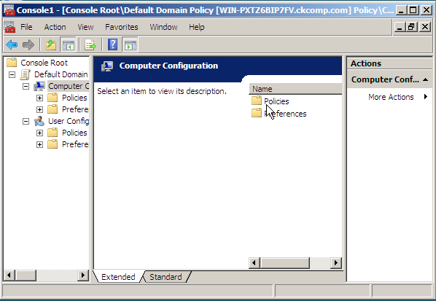  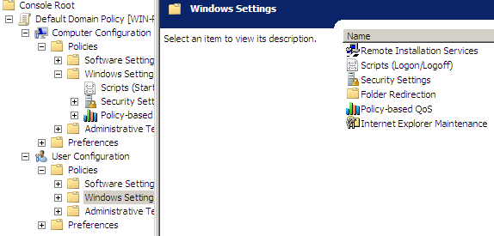  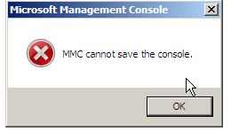 | I followed the steps given in the book. At step 19, I received an error message.

# | Page | Chapter/Activity | Status | Description
75 | 400 | 10-2 |  | Configuring Password Security

Screen Shot(s) | Documentation
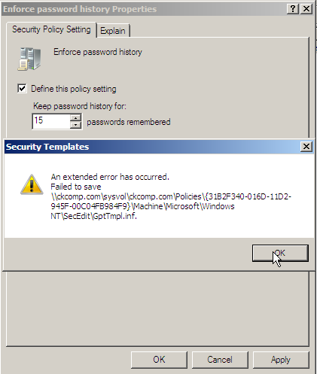  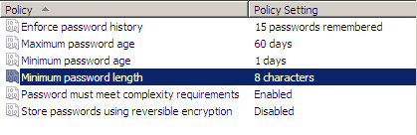 | I followed the steps given in the book, except step 1: because I could not save in activity 10-1, I left the window open to continue instead of saving. At step 7, I received an error message.  After shutting down my computer and leaving it off over night, I attempted to start over with activity 10-1. With only virtual PC running, I was able to get step 19 to work without any errors. I was also able to get activity 10-2 to work as long as absolutely everything else on my computer was closed.

# | Page | Chapter/Activity | Status | Description
76 | 403 | 10-3 |  | Configuring Account Lockout Policy

Screen Shot(s) | Documentation
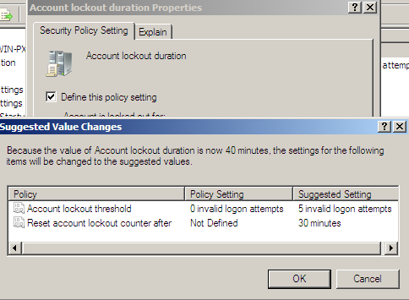 | I followed the steps given in the book.

# | Page | Chapter/Activity | Status | Description
77 | 405 | 10-4 |  | Configuring Kerberos Security

Screen Shot(s) | Documentation
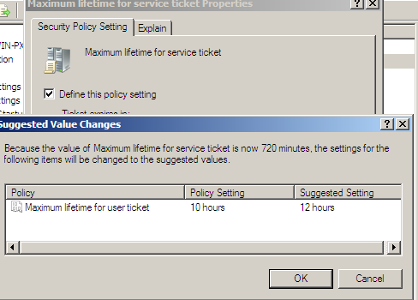 | I followed the steps given in the book.

# | Page | Chapter/Activity | Status | Description
78 | 406 | 10-5 |  | Configuring Auditing

Screen Shot(s) | Documentation
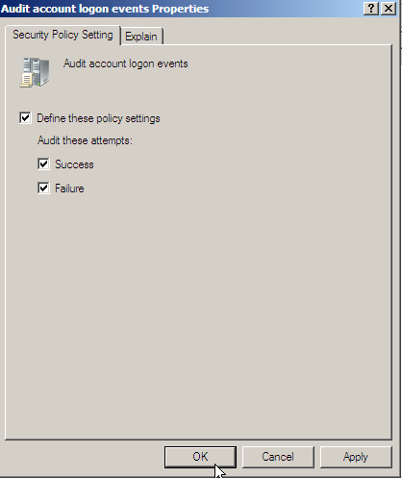 | I followed the steps given in the book.

# | Page | Chapter/Activity | Status | Description
79 | 408 | 10-6 |  | Configuring User Rights

Screen Shot(s) | Documentation
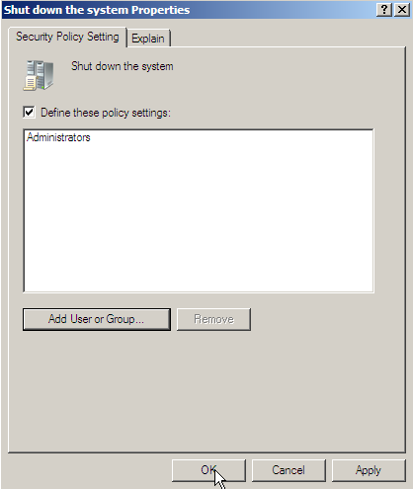 | I followed the steps given in the book.

# | Page | Chapter/Activity | Status | Description
80 | 410 | 10-7 |  | Configuring Security Options

Screen Shot(s) | Documentation
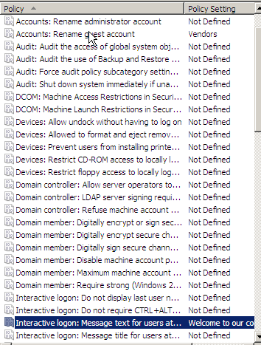 | I followed the steps given in the book.

# | Page | Chapter/Activity | Status | Description
81 | 412 | 10-8 |  | Configuring IPSec

Screen Shot(s) | Documentation
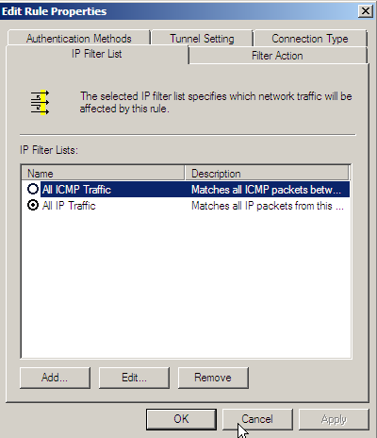  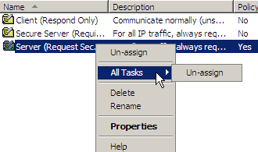 | I followed the directions given in the book.

# | Page | Chapter/Activity | Status | Description
82 | 415 | 10-9 |  | Using the Security Templates Snap-In

Screen Shot(s) | Documentation
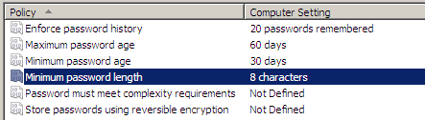  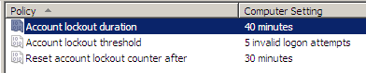 | I followed the steps given in the book.

# | Page | Chapter/Activity | Status | Description
83 | 417 | 10-10 |  | Using the Security Configuration and Analysis Snap-In

Screen Shot(s) | Documentation
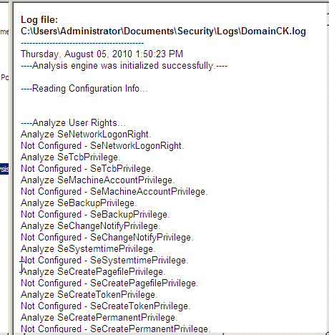  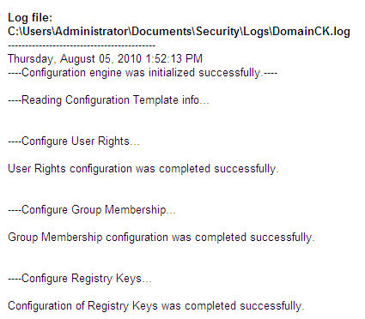 | I followed the steps given in the book.

# | Page | Chapter/Activity | Status | Description
84 | 419 | 10-11 |  | Configuring Policies to Apply to Clients

Screen Shot(s) | Documentation
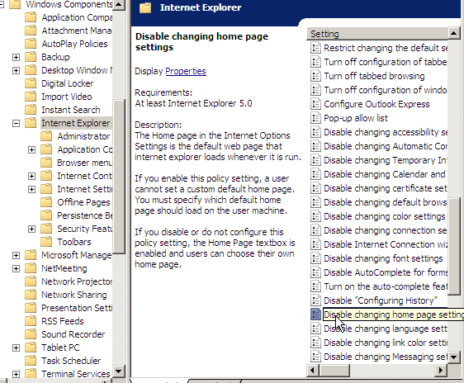 | I followed the steps given in the book.

# | Page | Chapter/Activity | Status | Description
85 | 425 | 10-14 |  | Using the cipher Command

Screen Shot(s) | Documentation
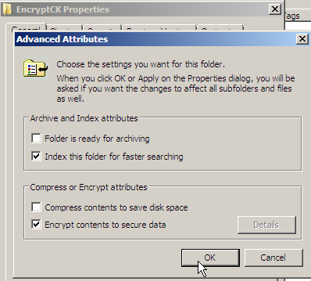  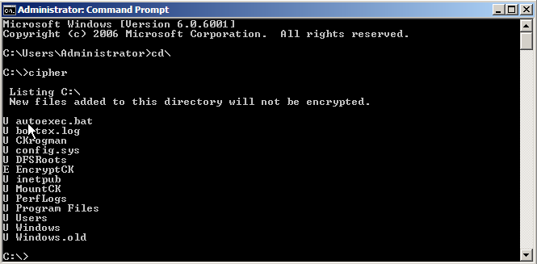 | I followed the steps given in the book.

# | Page | Chapter/Activity | Status | Description
86 | 427 | 10-15 |  | Installing BitLocker Drive Encryption

Screen Shot(s) | Documentation
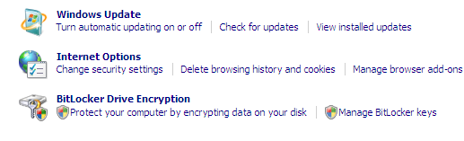 | I followed the steps given in the book.

# | Page | Chapter/Activity | Status | Description
87 | 431 | 10-18 |  | Configuring Windows Firewall Using the Snap-In

Screen Shot(s) | Documentation
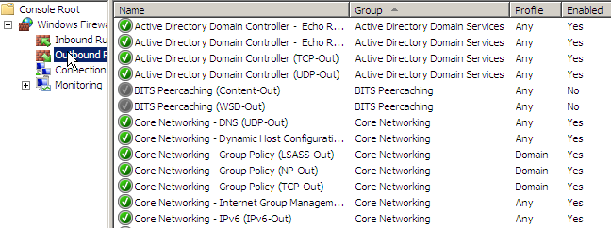  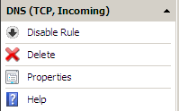 | I followed the steps given in the book.

